Practical Looping
- Print the integers from 1 to 20 using a while loop and the counter variable x. Assume that the variable x has been declared, but not initialized. Print only 5 integers per line. [Hint: Use the calculation x % 5. When the value of this is 0, print a newline character; otherwise, print a tab character.]
- The factorial of a non negative integer n is written n! (pronounced "n factorial") and is defined as follows:
n! = n · (n 1) · (n 2) · ... · 1 (for values of n greater than to 1)
and
n! = 1 (for n = 0 or n = 1).
For example, 5! = 5 · 4 · 3 · 2 · 1, which is 120. Write a program that reads a nonnegative integer and computes and prints its factorial.
- Write a program that displays a table of the Celsius temperatures 0 through 20 and their Fahrenheit equivalents. The formula for converting a temperature from Celsius to Fahrenheit is Fahrenheit = 1.8 x (Celsius) + 32 where F is the Fahrenheit temperature and C is the Celsius temperature. Your program must use a loop to display the table.
- Write a program that accepts five integers and return the smallest integer accepted.
- A palindrome is a number or a text phrase that reads the same backwards as forwards. For example, each of the following five-digit integers is a palindrome: 12321, 55555, 45554 and 11611. Write a program that reads in a five-digit integer and determines whether it is a palindrome. [Hint: Use the integer division and modulus operators to separate the number into its individual digits.]
- The owners of the Annan Supermarket would like to have a program that computes the weekly gross pay of their employees. The user will enter an employee’s ID number, the hourly rate of pay, and the number of hours worked for the week. In addition, Annan Supermarkets would like the program to compute the employee’s net pay and overtime pay. Overtime hours, any hours over 40, are paid at 1.5 the regular hourly rate. Net pay is Gross minus deductions. Assume that deductions are made up of income tax (at 15% of gross if the gross exceeds $500.00) and a $20 parking charge.
- The Syracuse (also called Collatz or Hailstone) sequence is generated by starting with a natural number and repeatedly applying the following function until reaching syr(x)=
For example, the Syracuse sequence starting with 5 is: 5,16,8,4,2,1. Write a program that gets a starting value from the user and then prints the Syracuse sequence for that starting value.
- Write a program that gets a value from the user and then prints mathematical table as show below. For example user input 7, it should print like this below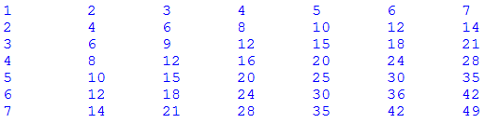
- Print these patterns using nested loop (in a program called PrintPattern1x). Use a variable called size for the size of the pattern and try out various sizes. You should use as few printing statements as possible.
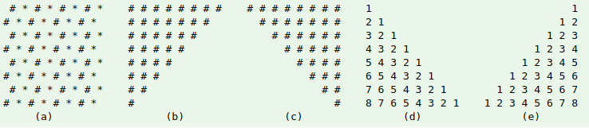
Hints:
The equations for major and opposite diagonals are row = col and row + col = size + 1. Decide on what to print above and below the diagonal.

- Print the timetable of 1 to 9, as follows, using nested loop. (Hints: you need to use an if-else statement to check whether the product is single-digit or double-digit, and print an additional space if needed.)
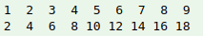

- Write a program which ask the user to two numbers and then print LCM and GCD

